**Database Notes & Information**

Building Tables and Relationships

Import Data from Excel

[**Importing**](javascript://) enables you to quickly copy data from an external file into an Access database. You can import data from many sources, such as another Access database; Excel spreadsheet; SharePoint site; Outlook email; or text files in an HTML, XML, or delimited text file format. In a [**delimited text file**](javascript://), data is separated by a common character, the [**delimiter**](javascript://), such as a comma, tab, or dash. A [**CSV (comma-separated value)**](javascript://) file is a common example of a delimited text file. An [**XML file**](javascript://) contains the data surrounded by [**Extensible Markup Language (XML)**](javascript://) tags that identify field names and data. The most common file format for importing data into an Access database is [**Microsoft Excel**](javascript://), the spreadsheet program in the Microsoft Office suite.

**Get External Data - Excel Spreadsheet** A dialog box used to import data from an external file into an Access database.

**Import** A process that lets you copy the data from an external source, without having to open the source file, and add it to the current file, such as an Access database, a worksheet, or a publication.

**Append** To add records to an existing table. (In order to append data to an existing table, the column names of the Excel spreadsheet must match the field names in the Access table.)

**Link** In Access, to connect a database to data in an external file such as another Access database table; an Excel or other type of spreadsheet; a text file; an HTML file; or an XML file.

**Linking** In Access, to connect a database to data in an external file such as another Access database table; an Excel or other type of spreadsheet; a text file; an HTML file; or an XML file.

**Quick Tip** Updates to linked data made in the original data source are reflected in the Access database, but linked data cannot be changed in Access.

**Import Spreadsheet Wizard** A series of screens that guides you through the steps of importing data from Excel into an Access database.

**Primary key field** A field that contains unique information for each record. A primary key field cannot contain a null entry.

Modify Fields in Datasheet View

**Design View** A view in which the structure of an object can be manipulated. (most commonly used to modify fields)

**Datasheet View** A view in Access that shows a table as a collection of rows and columns, similar to a spreadsheet. (most commonly used find and examine several records in a spreadsheet-like view of information, you can also use Datasheet View to add, delete, and modify fields)

**Currency versus Number Data Type**

In general, if a number represents a **fractional** value (such as dollars and cents, not a whole number), choose Currency for its data type. The underlying reason that all fractional values should be given a Currency data type is that a computer works with numbers using a binary system (1s and 0s), which cannot accurately store decimal fractions such as 0.1 or 0.01. The system can lead to rounding errors that all programming languages must address. In Access, the Currency data type includes special code to avoid these errors. If you are working with **integer** (a whole number, not a fraction) data, however, the Number data type provides faster performance. Whether you choose the Currency or Number data type, you can format the data to look as desired.

Modify Number and Currency Fields

Number and Currency fields have similar properties because they both contain numeric values. The [**Currency**](javascript://) data type is best applied to fractional values such as those that represent money down to the cent. The [**Number**](javascript://) data type is best used to represent integer values, whole numbers such as quantities, measurements, and scores.

**Currency** In Access, a numeric format within the Format property that displays numbers with a currency symbol. Also a data type for fractional values such as those that represent money.

**Number** In Access, data type that represents integer values, or whole numbers, such as quantities, measurements, and scores.

**Quick Tip** Scroll to the right side of the datasheet to find the Click to Add field name placeholder.

**Default Value** A value that Access will display on the screen in a particular field before the user begins adding a record.

**Table Design View** A view of a table that provides the most options for defining fields.

Number Field Size Property Options

| **property** | **description** |
| --- | --- |
| Byte | Stores numbers from 0 to 255 (no fractions) |
| Integer | Stores numbers from –32,768 to 32,767 (no fractions) |
| Long Integer | Stores numbers from –2,147,483,648 to 2,147,483,647 (no fractions) |
| Single | Stores numbers (including fractions with six digits to the right of the decimal point) times 10 to the –38th to +38th power |
| Double | Stores numbers (including fractions with more than 10 digits to the right of the decimal point) in the range of 10 to the –324th to +324th power |

**Quick Tip** Double-click a property name to toggle through the choices.

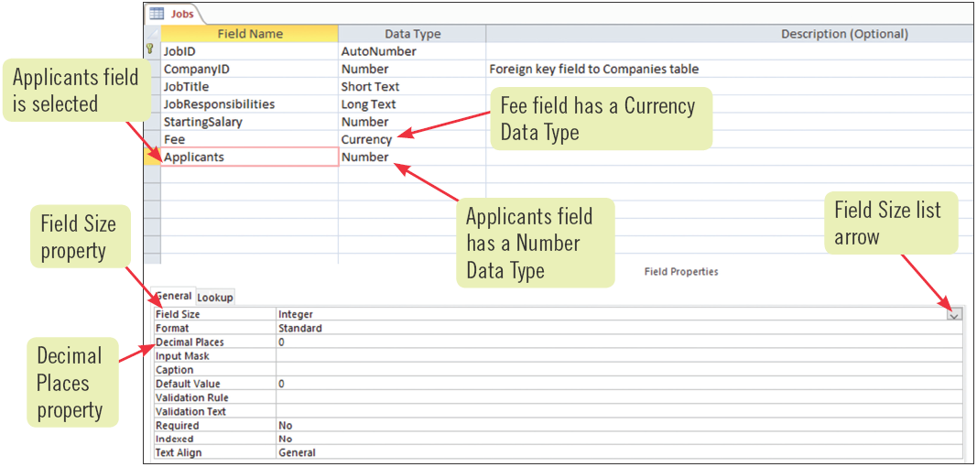

Modify Short Text Fields

**Short Text** In Access, a data type that allows field values containing letters, digits, and other characters. (most common and therefore the default field data type)

**Input Mask** A field property that provides a visual guide for users as they enter data.

Common Short Text Field Properties

| **property** | **description** | **sample field** | **sample property entry** |
| --- | --- | --- | --- |
| Field Size | Controls how many characters can be entered into the field | State | 2 |
| Format | Controls how information will be displayed and printed | State | > (displays all characters in uppercase) |
| Input Mask | Provides a pattern for data to be entered | Phone | !(999) 000-0000;1;_ |
| Caption | Describes the field in the first row of a datasheet, form, or report; if the Caption property is not entered, the field name is used to label the field | EmpNo | Employee Number |
| Default Value | Displays a value that is automatically entered in the given field for new records | City | Des Moines |
| Required | Determines if an entry is required for this field | LastName | Yes |

### Working with the Input Mask Property

The Input Mask property provides a **pattern** for data to be entered, using three parts, each separated by a **;** (semicolon). The first part provides a pattern for what type of data can be entered. For example, **9** represents an optional number, **0** a required number, **?** an optional letter, and **L** a required letter. The second part determines whether all displayed characters (such as dashes in a phone number) are stored in the field. For the second part of the input mask, a 0 entry stores all characters, such as 555-1199, and a 1 entry stores only the entered data, 5551199. The third part of the input mask determines which character Access uses to guide the user through the mask. Common choices are the asterisk (*), underscore (_), or pound sign (#).

Modify Date/Time Fields

**Date/Time** A data type that stores dates, times, or both.

**Format** The process of changing the appearance of text and objects.

**Date()** An Access function that returns the current date.

**Date Picker** A pop-up calendar you can use to select dates.

**Required** A property that specifies whether a value is required for a field. Access displays an error message if you attempt to enter a record without including a value in this field.

### Entering Dates

If you type the date for a Date/Type field instead of choosing a date from the pop-up calendar, Access assumes that years entered with two digits from 30 to 99 refer to the years 1930 through 1999, and 00 to 29 refers to the years 2000 through 2029. To enter a year before 1930 or after 2029, you must type all four digits of the year.

### Using Smart Tags

**Smart Tags** are buttons that automatically appear in certain conditions. They provide a small menu of options to help you work with the task at hand. For example, in Table Design View, Access provides the **Property Update Options** Icon Smart Tag to help you quickly apply property changes to other objects of the database that use the field. Another Smart Tag, the **Error Indicator** Icon helps identify potential errors.